
Spot the difference game
Assesment 3

BY
Pratik Marasini (S400934)
Dharma Bahadur Budhathoki (S395172)
Wahim Bin Alam (S398923)

Table of Content
1 Introduction 3
2 Objectives 3
3 Technology Used 4
3.1 System Design 4
3.1.1 Image processing module 4
3.1.2 GUI model 4
3.1.3 Difference Detection Module 4
4 OOP Concepts used 5
4.1 Encapsulation 5
4.2 Inheritance 6
4.3 Polymorphism 7
4.4 Class Interaction / Composition 8
5 Features Implemented 9
5.1 Main Game Interface (GUI Layout) 9
5.2 Image Loading Process 10
5.3 Gameplay Interaction (Difference Detection) 11
5.4 Reveal Functionality 13
6 Implementation Details 14
6.1.1 GUI Development 14
6.2 Image Processing 14
6.3 Difference Storage 15
7 Challenges Faced 15
8 Testing 15
9 Advantages 16
10 Limitations 16
11 Future Improvements 16
12 Conclusion 17
13 Group Member Contributions 18
14 References 18

Table of figures
Figure 1: Encapsulation 4
Figure 2: Inheritance 5
Figure 3: Polymorphism 6
Figure 4: class Interaction /composiiton 7
Figure 5: main game interface 9
Figure 6: Image Loading Process 10
Figure 7: Gameplay Interaction (Difference Detection) 11
Figure 8: Reveal Functionality 13

Introduction
In the present days computer vision and graphical applications are taking a significant role in the software systems. Applications of image processing are widely used in game, security systems, medical software and automation technologies. This project is about creating a desktop version of the “Spot the Difference” game in Python.
The game will show two pictures to the user:
- Original image
- Hidden Differences Modified Image
The player clicks the image that is different. Application then verifies selected area as being correct or not. The project is a blend of image processing with OpenCV and GUI development with Tkinter.
The project demonstrates:
- Event-driven programming
- GUI development
- Object-oriented programming
- Image processing techniques
- Randomized game logic

Objectives
This project aims to:
- Create a computer game that runs on a computer using the Python programming language.
- To incorporate the concepts of an Object Oriented Program into the program.
- To create a graphical user interface (GUI) with tkinter
- To process images using OpenCV.
- To create random image differences automatically
- To be used for an interactive gaming experience

Technology Used
Technology | Purpose
Python | Main programming language
Tkinter | GUI development
OpenCV | Image processing
Pillow (PIL) | Image display support
Randomize module | Random difference making

System Design
The application is made up of three modules:

Image processing module
This module handles:
- Loading images
- Creating random differences
- Applying image effects
- Resizing images

GUI model
This module handles:
- Buttons
- Labels
- Image display canvases
- User interaction
- Event handling

Difference Detection Module
This module:
- Stores difference coordinates
- Detects mouse clicks
- Checks correct selections
- Monitors errors and improvements

OOP Concepts used
The project is a successful example of the use of Object Oriented Programming concepts.

Encapsulation
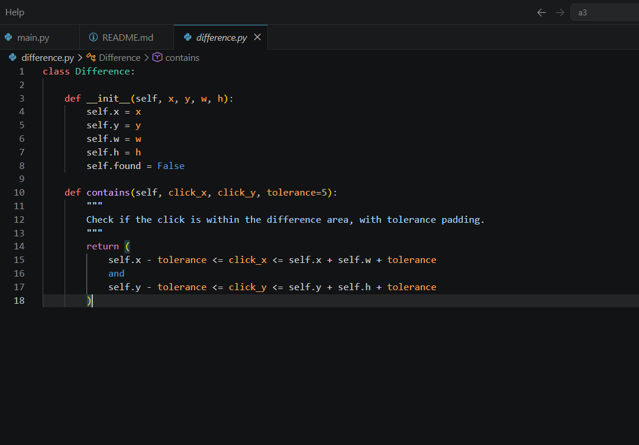
Figure 1: Encapsulation
The Difference class demonstrates encapsulation by bundling related data such as x, y, w, h, and found into a single unit. These values represent a difference region in the image.
Instead of allowing direct uncontrolled access, the class provides controlled methods to interact with this data safely. This helps protect the internal state and keeps the logic organized and secure.

Inheritance
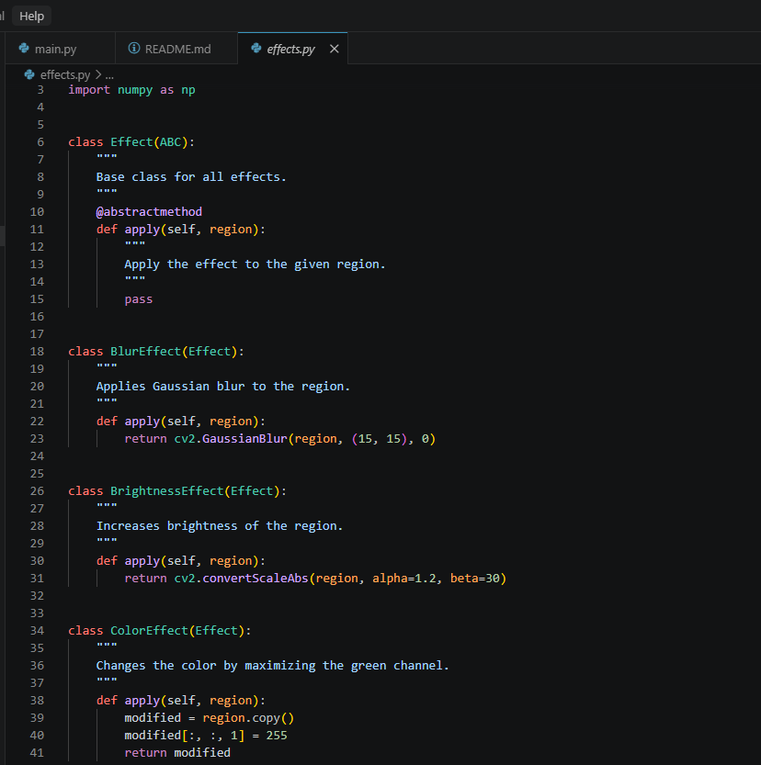
Figure 2: Inheritance
The Effect class acts as a base (parent) class, defining a general structure for all effects.
Other classes like BlurEffect, BrightnessEffect, ColorEffect, PixelEffect, and NoiseEffect inherit from it. This means they reuse the shared structure but can also extend or modify it based on their specific behavior.
Inheritance helps reduce code duplication and makes the system easier to extend with new effects.

Polymorphism
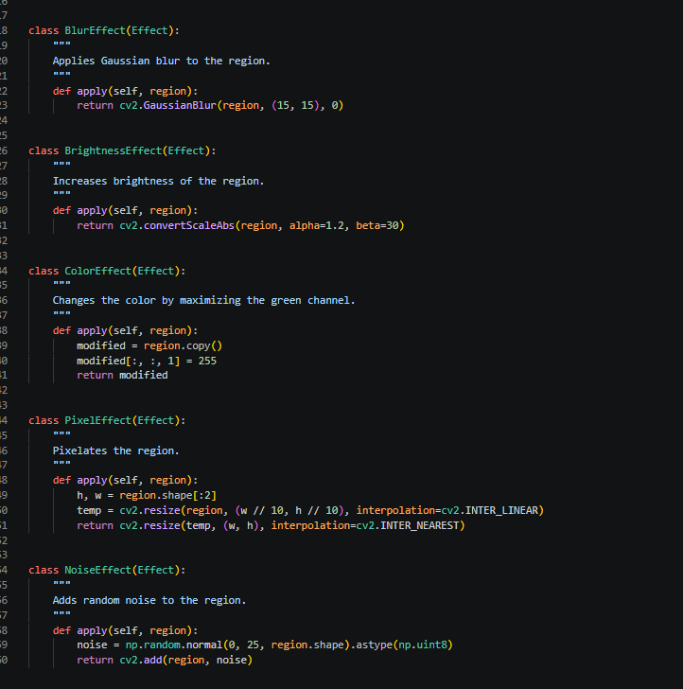
Figure 3: Polymorphism
Polymorphism is clearly shown through the apply(self, region) method.
Each subclass implements this method in its own unique way. For example:
- BlurEffect applies a blur
- BrightnessEffect adjusts brightness
- NoiseEffect adds random noise
Even though they share the same method name, each class behaves differently. This allows the program to treat all effects in a consistent way while still producing different results depending on the object type.

Class Interaction / Composition
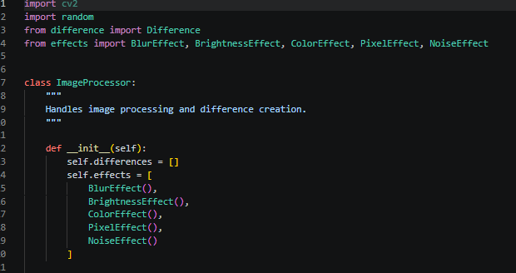
Figure 4: class Interaction /composiiton
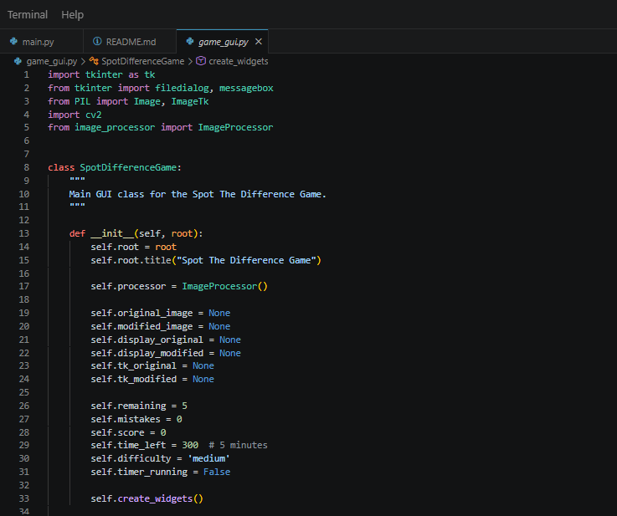

The ImageProcessor class works by combining (composing) other classes like Difference and Effect. It uses them together to detect and generate image differences.
In game_gui.py, the SpotDifferenceGame class connects the user interface with the game logic by using ImageProcessor. This shows how different classes collaborate to build a complete working system.

Features Implemented
This section presents visual evidence of the implemented system, demonstrating GUI functionality, image processing, and game interaction.

Main Game Interface (GUI Layout)
This figure shows the complete user interface of the Spot The Difference Game. It includes the original image on the left, modified image on the right, along with control buttons, score display, Time left and mistake counter. The layout is designed using Tkinter for a clean and user-friendly experience.
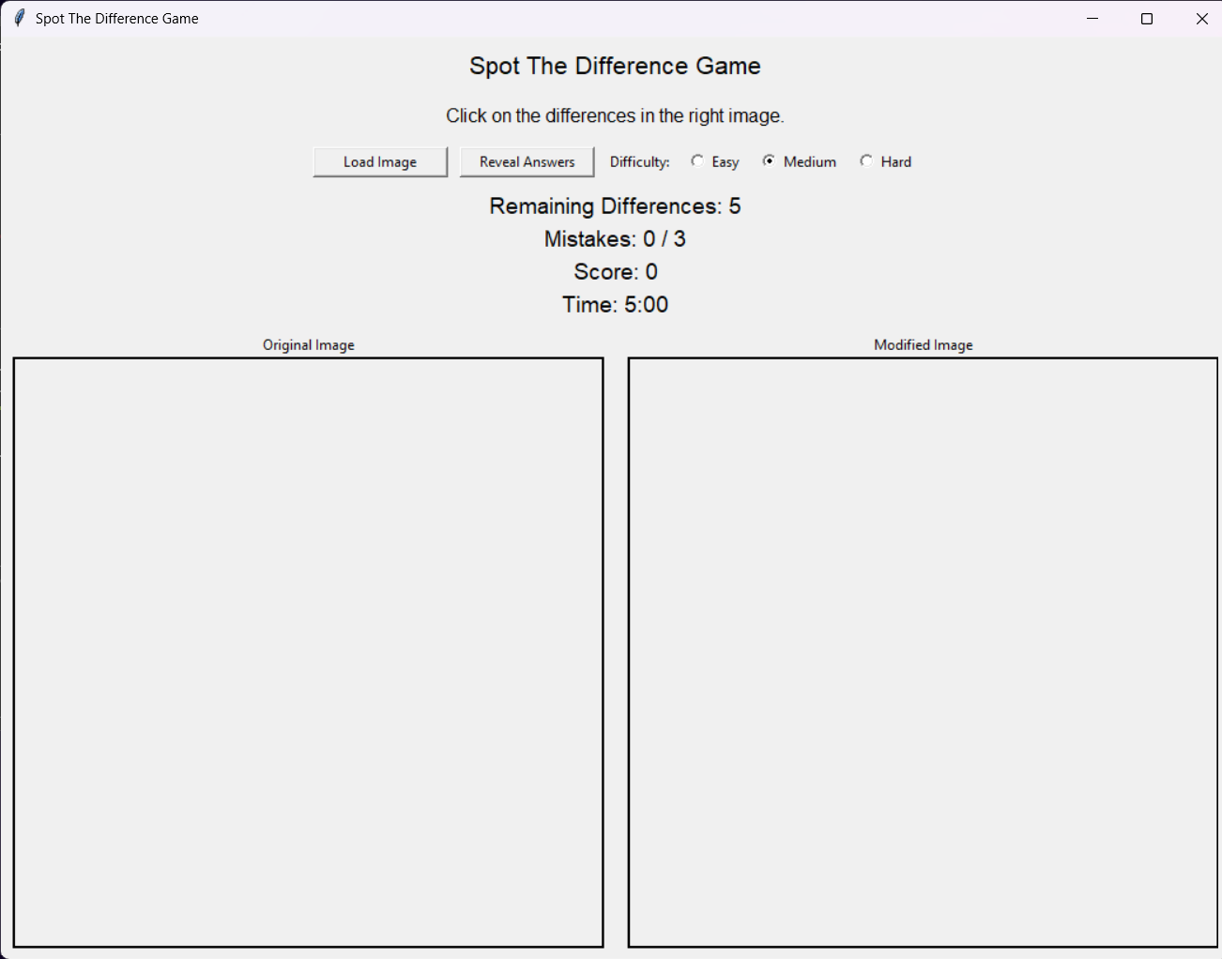
Select attempt left
selected right
Game time left
Game score
Game level
Reveal answer button
Load image button
Figure 5: main game interface

Image Loading Process
This figure shows the image loading functionality. The user selects an image from the local system using a file dialog, and the application displays it in both original and modified formats.
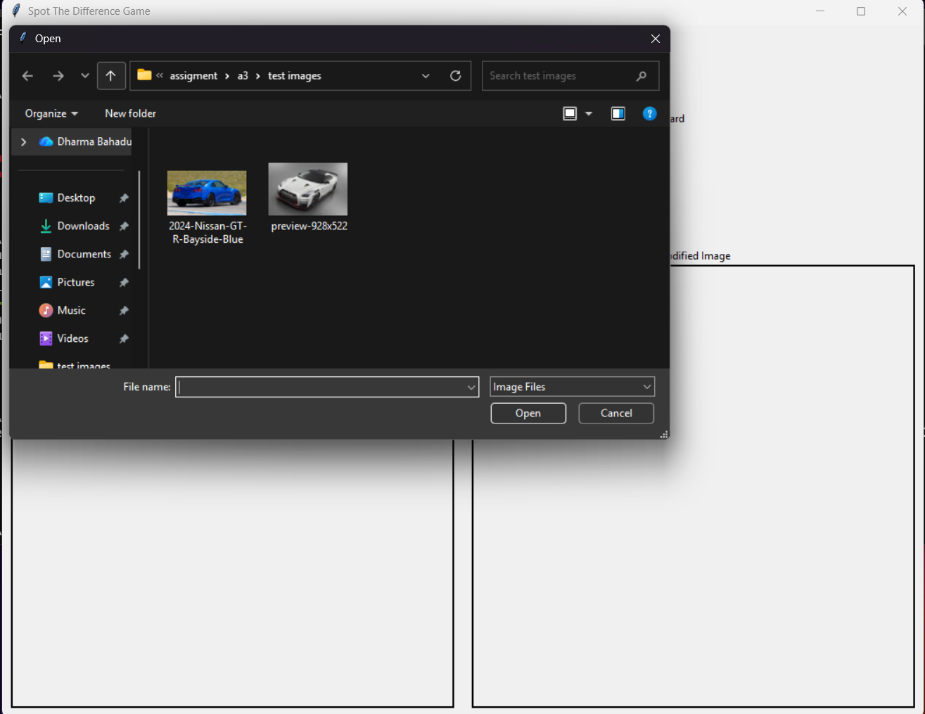
Figure 6: Image Loading Process

Gameplay Interaction (Difference Detection)
This figure shows active gameplay where the user identifies differences by clicking on the modified image. Correct selections are marked with red circles, and the remaining difference counter updates in real time.
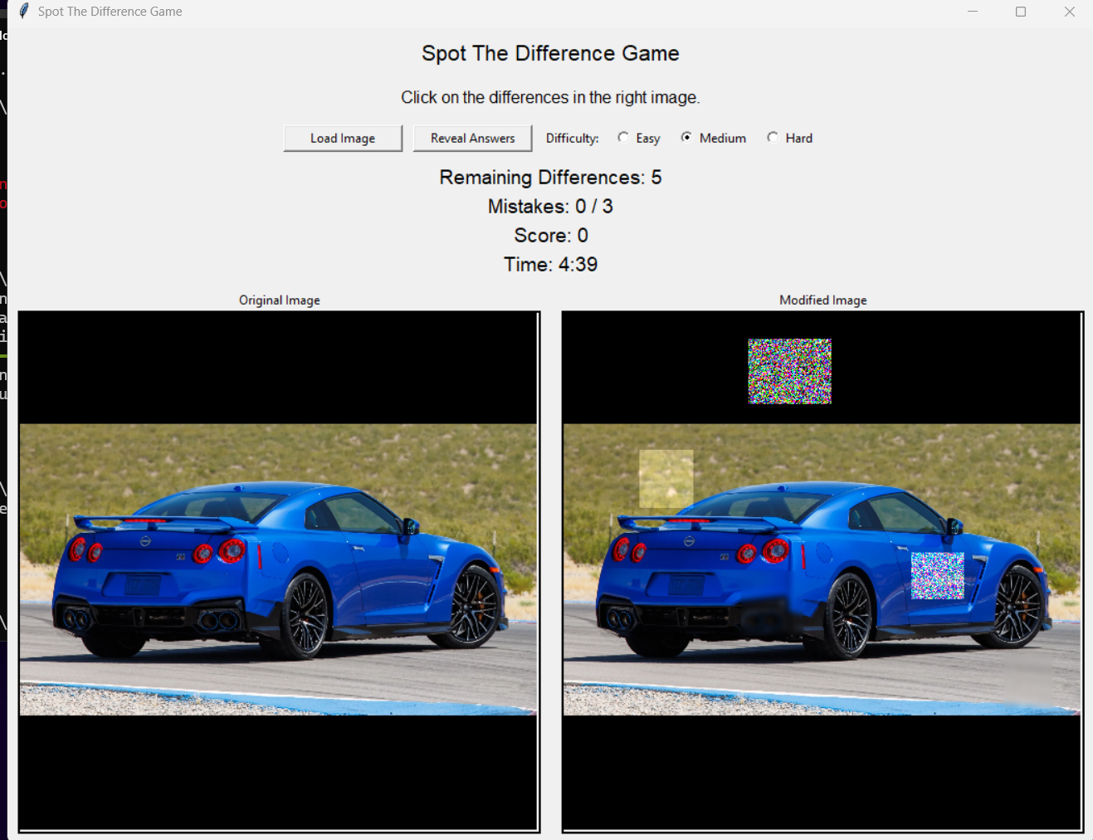
differences
Figure 7: Gameplay Interaction (Difference Detection)

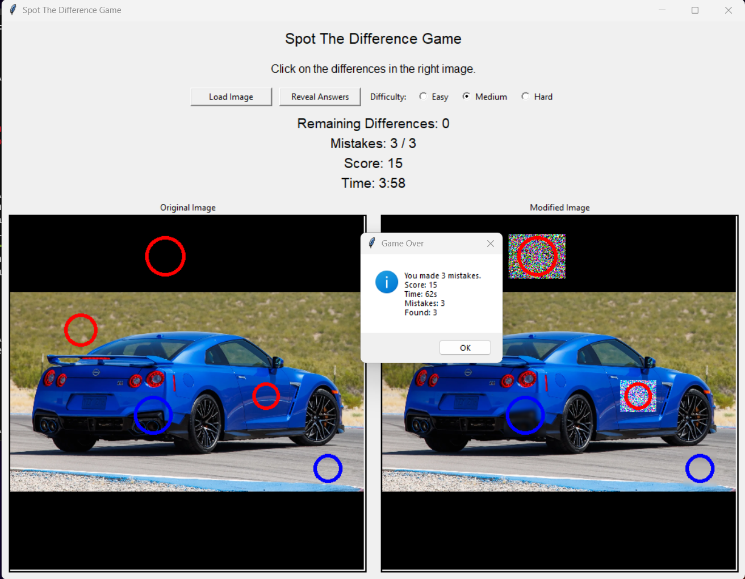

Reveal Functionality
This figure shows the reveal feature, where all remaining hidden differences are displayed using blue circles on both images. This helps the player identify missed differences and complete the round.
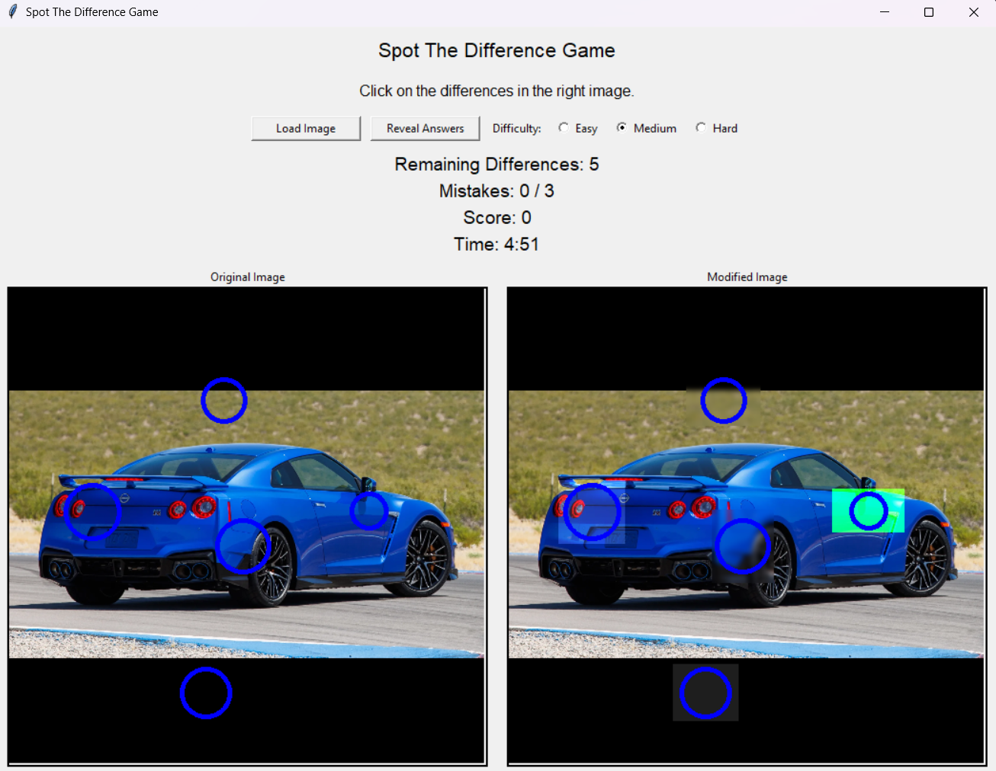
Figure 8: Reveal Functionality

Implementation Details

GUI Development
The following was created using tkinter:
- Buttons
- Labels
- Canvases
- Message boxes
The user interface is easy to use and simple.

Image Processing
Use of OpenCV for:
- Image resizing
- Blur effects
- Brightness manipulation
- Color modification
- Rectangle drawing

Difference Storage
The hidden difference stores:
- X coordinate
- Y coordinate
- Width
- Height
- Found status

Challenges Faced
There were some problems to face during development:
- Installing Python libraries
- Converting OpenCV image to Tkinter
- Displaying images inside canvases
- Preventing overlapping differences
- Detecting mouse clicks accurately
- Troubleshooting indention and module errors.
Testing and debugging was used to solve these issues.

Testing
Various images and interactions were used for testing the application.
Test Case | Result
Load Image | Passed
Generate Differences | Passed
Click Detection | Passes
Reveal Differences | Passed
Mistakes Counter | Passed
Game-over Condition | Passed
GUI Display | Passed

Advantages
- Interactive and user-friendly
- Prominently communicates ideas about image processing
- Implements object-oriented programming
- The design of simple desktop applications.
- Future improvements will be possible, with this designed to be expanded.

Limitations
- Only supports desktop systems
- Fixed image dimensions
- Limited to 5 differences
- No score-saving system

Future Improvements
Further improvements include:
- Sound effects
- Advanced image effects

Conclusion
The “Spot the Difference” Game project successfully illustrates the implementation of Python programming, Tkinter GUI Development, and OpenCV image processing. The application offers an interesting user experience and demonstrates essential software engineering concepts like object-oriented programming, event handling and image manipulation.
All the project's goals were met and the project is a good example of a desktop application, built with Python. In this project, important technical skills like GUI development, debugging, image processing and software designing are successfully applied.

Group Member Contributions
Members | Contributions
Dharma Budathoki | Led the overall project development including GUI design, image processing implementation, game logic, testing, debugging, report writing, and README file creation. Also integrated features, organized code structure, and added and edited screenshots for documentation.
Pratik Marasini | Assisted with GUI development and contributed to report writing and documentation.
Wahim Alam | Game Assets

References
Python Software Foundation. (2024). Python Documentation. Retrieved from https://docs.python.org/3/
OpenCV Organization. (2024). OpenCV Documentation. Retrieved from https://docs.opencv.org/
Tkinter Documentation. (2024). Tkinter GUI Library. Retrieved from https://docs.python.org/3/library/tkinter.html
Pillow Documentation. (2024). Pillow Imaging Library. Retrieved from https://pillow.readthedocs.io/
Sweigart, A. (2020). Automate the Boring Stuff with Python. No Starch Press.

